Solution Design — Automated RFP-to-Project Flow
Oct 31, 2026 · @Subhashini
Six AI agents take the California RFP to a signed contract; no stage advances until a named person approves it at a human checkpoint. Bottleneck numbers refer to the top-5 ranking.

Workflow
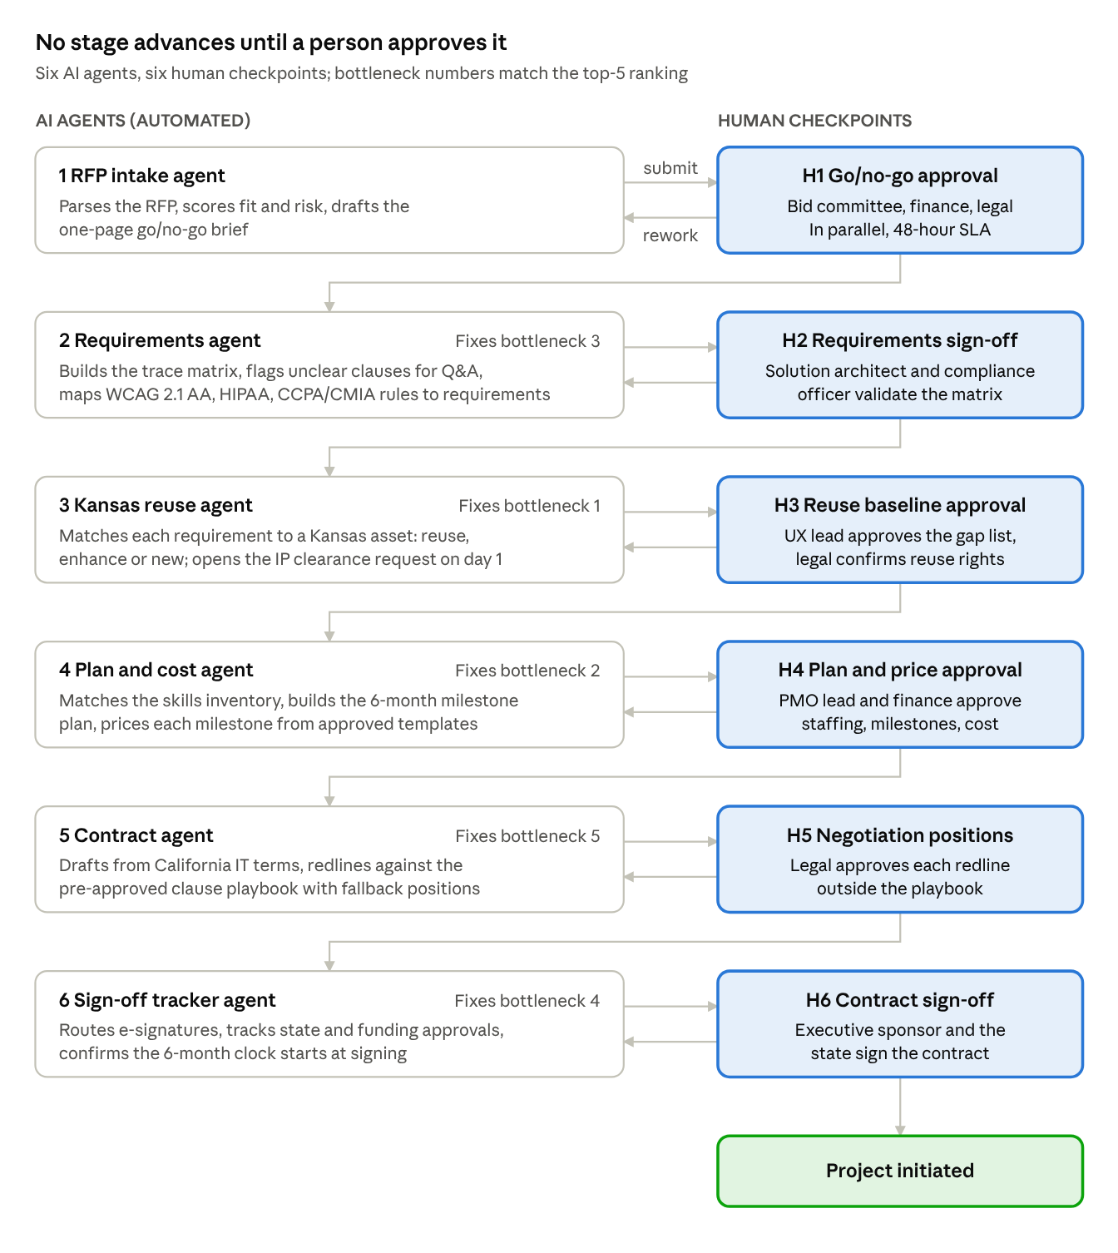
RFP-to-contract workflow · 6 agents, 6 human checkpoints
Each agent submits its output to a checkpoint; the approver either passes it to the next stage or returns it for rework. RFP approval (H1) has no top-5 bottleneck; it is sped up by parallel approvals with a 48-hour SLA.

Architecture
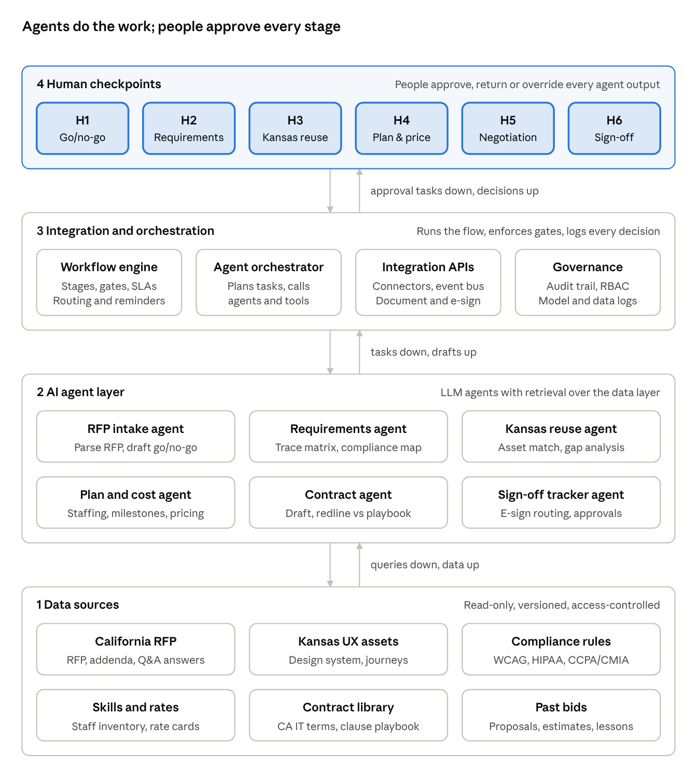
Solution architecture · 4 layers
Data sources feed the agents through retrieval; the orchestration layer runs the six stages, routes each agent draft to its checkpoint and records every decision in the audit trail.

